**Assignment 0**

1. Create a simple shell script to tell the user about their session – they

need to know:

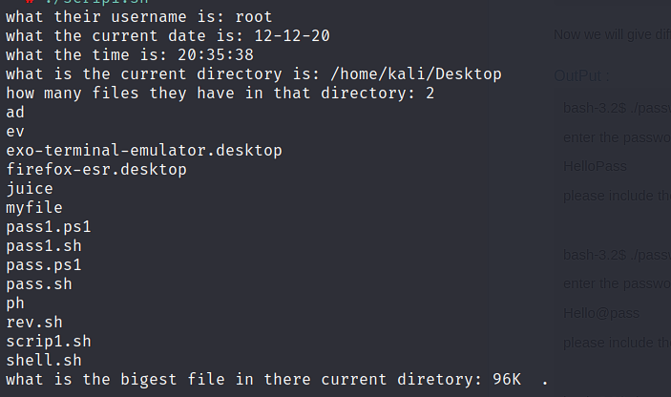

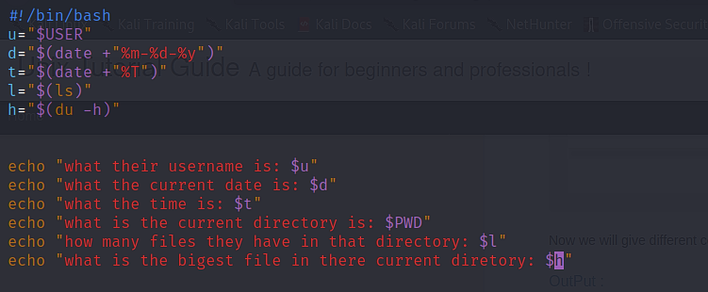

**Assignment 1**

Create a directory with a few test files in it (the files can be empty). Now write a script that for

every file in that directory you rename it to have an extension of today's date in YYYYMMDD

format.

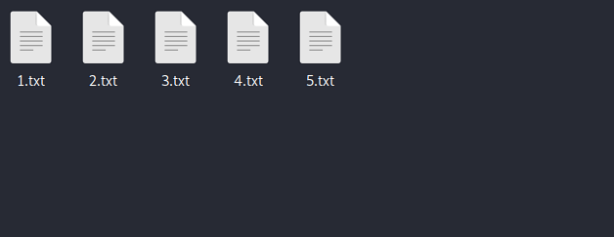

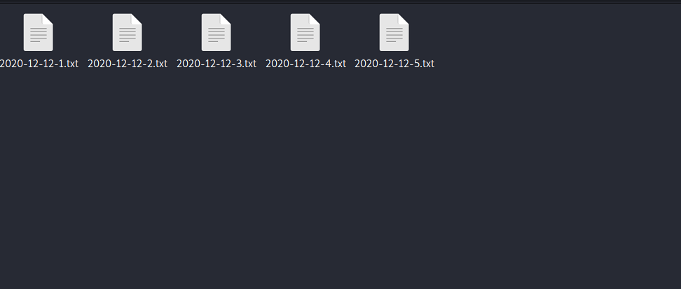

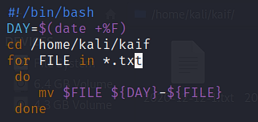

**Assignment 2**

Write a script that takes a number as an input and reverses it out to the user. For example, if the original number is 74985, the output should be 58947.

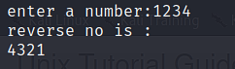

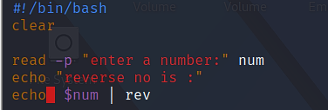

**Assignment 3**

Write a script to validate how secure someone's password is. Things you would care about:

● Length should be 8 or more characters

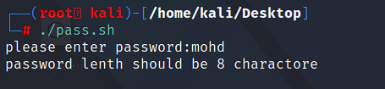

● The password should contain numbers and letters



● There should be both uppercase and lowercase letters



